**Lab 8: Memories**

Freddie Boadu

ECEN 328

Mansi Bhavsar

April 17, 2019

**Introduction:**

The lab was about teaching students about memories using ROMS. The students learned study the characteristics of memory, create schematic designs for memory, and test the designs on the target board. The lab also taught the students how to do use basic gates to make a rom. The students learned the significant of memory.

**Materials:**

* Xilinx ISE software, student or professional edition V14.7
* Digilent Basys2 board with an XC3S100E device.

**Methods:**

The student was asked to make a new project called ROM lab. The student is asked to add a ROM to the project. The init of the ROM is to be changed to 0F10. The input attached with IBUFS (SW0:SW2) will be covered. The student is to show the finished product to the instructor.

**Data:**

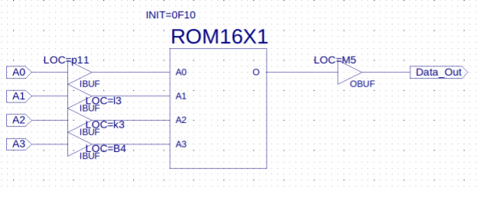

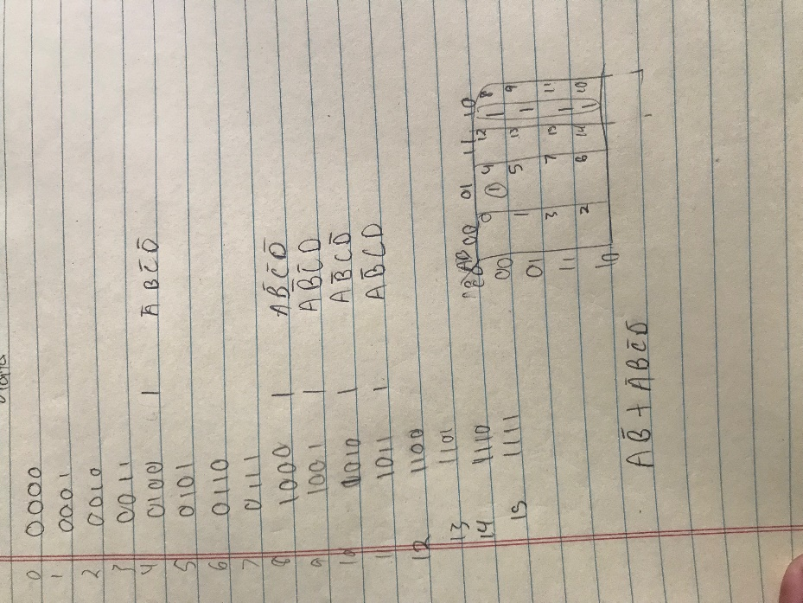

**Results and Discussion:**

The schematic yields the results of 4,8,9,10,11 being high on the board. This represented what was going on in the ROM during the time of being on. The student used the switches and tested each number 0-15 in binary. The sum of product equation for the ROM is A’BC’D’+ AB’C’D’+ AB’C’D +AB’CD’ +AB’CD.

**Design Challenge:**

This part of the lab requires a student to find a reduced equation. The student made a Kmap to find the equation. The challenge requires the student to recreate the ROM using basic gates and inverters. The student results are AB’ +A’BC’D’. The schematic looks like: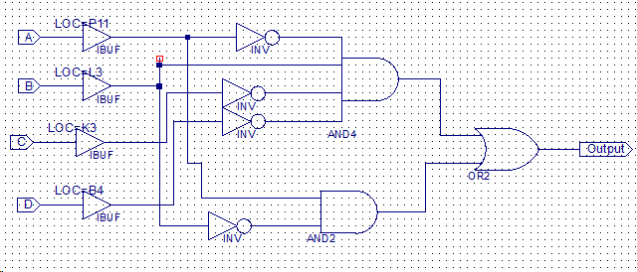

**Conclusion:**

The lab taught students about memory using a Rom and how to construct it. The student also learned how to make a 16 x 1 ROM using only basic gates.